Course -CI Airgun – Nov 19
NSRA SW Region Training
Club Instructor Airgun Course
Course Details and Booking Form
Date: Saturday 16th and Sunday 17th November 2019
Start Time: 09:00 for 09:15 Finish Time: 17:15 both days
Venue: Bournemouth Small Bore Rifle & Pistol Club, Chapel Gate Sports complex adjacent to Bournemouth International Airport, BH23 6BL
Cost: £90 Scouts mem no and group/district, £100 shooting clubs, £110 commercial
The course fee includes an NSRA course handbook, DBS check (if needed) and certificate (valid for 5 years).
Notes: Applications for places will be accepted with payment only.
Tea and coffee will be supplied but bring your own food, no accommodation.
Outline: The course is to give students the ability to provide instruction in the disciplines of Air Rifle and Air Pistol at club level. The course is suited to those with experience as a shooter, instructor or coach. Course tutors Chrissy Monksummers, Gary Pidgeon, Craig Powis.
To be certificated on successful completion of the course students must be individual members of the NSRA or current members of the Scout Association, and also have completed an RCO qualification or hold a valid YPST qualification. Those who are not members of either Scouting and/or the NSRA, or do not hold a current RCO (or YPST) qualification may complete the course and received a “Basic Techniques Certificate” which may subsequently be upgraded as and when the necessary membership / RCO (YPST) qualification is in place.
Students are required to bring their own rifles/pistols .177 air only, air (some will be available), ammunition and related equipment to the course, it is for the student to ensure the equipment and its transportation meets legal requirements.
Questions / Queries / “Special Requirements”
If you have any queries or special requirements please contact Chrissy Monksummers – NSRA SW Region Head Coach (Coach Education) 01747 822202, mob 07799 834747, email chrissy.monksummers@sky.com
Please complete lower half and return with payment to secure place, cheque payable to Chrissy Monksummers by 2nd November 2019. Bacs to First Direct Bank sort code 40-47-78 Account number - 20452904
………………………………………………………………………………………………………………………………………………
Course CI Airgun – Nov 19
Name: .......................................................................................(Please Print Clearly)
Address:

Telephone No. ....................................................... or ………………..……………………..……..
Email:...............................................................................................
NSRA Mem. No. ……………..……………. Club: ……………………………………………………….….……………………..
Scout Association Mem. No. …………………….Scout Group & District: ...............................................
RCO or YPS No………………………dated………………….. and valid until……………………………
I declare that I am not prohibited from possessing a firearm or ammunition by virtue of section 21 of the Firearms Act 1968 as amended and that I am over the age of 18.

Signed ……………………………………………
Please return to - Chrissy Monksummers, 29 Cloverfields, Gillingham, Dorset SP8 4UP

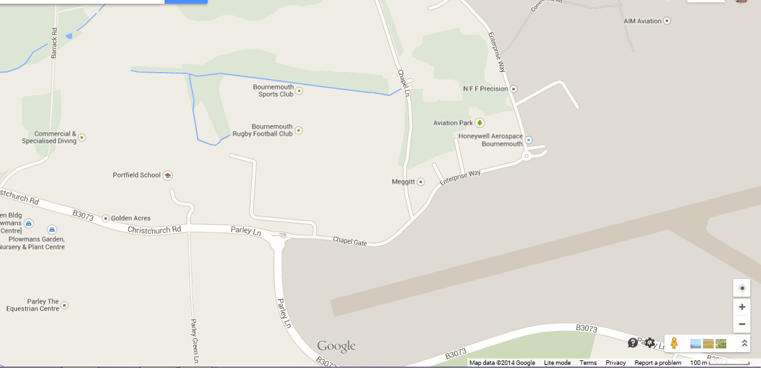
Access via entrance to Chapel Gate Sports Complex
Bournemouth Airport
Range
Bournemouth Small Bore Rifle & Pistol Club is located in the Heygate Vernon Range with-in the Chapel Gate Sports complex adjacent to Bournemouth International Airport

